CST205: Multimedia Design & Programming

Craig Calvert &

**Midterm Outline**

**Objective**

Create two custom Instagram filters.

**Instagram Image Sizes**

Square Image: 1080px in width by 1080px in height

Vertical Image:   1080px in width by 1350px in height

Horizontal Image:  1080px in width by 566px in height

**Filter #1: CSUMBy (The 25th Anniversary Edition)**

1. Topic
   1. We are creating a filter to help celebrate CSUMB’s 25th anniversary, which will run from the fall 2019 semester to the Spring 2020 semester. As an official logo for the celebration hasn’t been unveiled, we have taken it upon us to design one for our use. The filter is going to take an image and fade it. Once the image has been faded the 25th anniversary logo will be superimposed on top of it.
2. Example

A sign in a field


1. Sources
   1. <https://csumb.edu/affairs/color-palette>  
      The official color palette from CSUMB is being used for the colors in the 25th Anniversary logo.
   2. <https://csumb.edu/25>  
      Information regarding the 25th anniversary of CSUMB.
   3. <https://computergraphics.stackexchange.com/questions/1833/instagrams-fade-effect>  
      We used this as the starting point for working on the image fade. Here we found the formula of x′=0.77x+38 which we are using as a base for the image fade.
2. Project progress update
   1. This filter is coming along nicely. We have taken the formula from above and have made adjustments to it where we are getting a fade such as the one represented in our example photo. We still need to make some graphical tweaks to the 25th anniversary logo and have finalize how we want to overlay the logo on the image.

**Filter #2: BlurryWurldy**

1. Topic
   1. Create a filter that centers a pair of glasses on the image. The image is blurred except for those areas where the glass lenses would be located.
2. Example

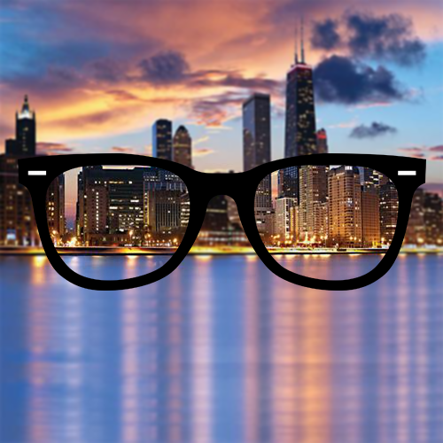

1. Sources
   1. Some of the sources we have used for researching the blurring effect are:
      1. <http://www.jhlabs.com/ip/blurring.html>  
         Though this website is focused on the Java language, runs through a series of other possible blurring options (Box Blur, Gaussian Blur, Motion Blur, Spin and Zoom Blur, Faster Motion Blur, Blurring by Fourier Transform, and Threshold Blurs).
      2. <https://mmeysenburg.github.io/image-processing/06-blurring/>  
         Another website providing a more in-depth look at average blur and Gaussian blur.
      3. <https://www.youtube.com/watch?v=8iIPlNNUWfc>  
         This video demonstrates one possible way of blurring an image using JES and python.
2. Project progress update
   1. We have started working on applying the blurring effect to an image. However, at this point, we haven’t been able to achieve the amount of blur we would like to apply to the image. We have also been discussing how we want to handle different image sizes and the placement of the glasses. Do we restrict the size? Can it only be a certain ratio? These are some of the questions that we are working on providing answers to. Graphically, we are also considering changing the color of the glass frames to a color that is going to work with images that are both dark in color and light in color.